**SYWARD PLACE**

**40-48 PYRCROFT ROAD**

**CHERTSEY**

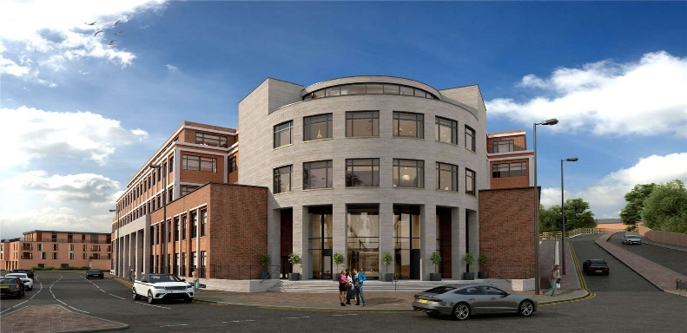**KT16 9RL**

**Access to the block:**

To access your apartment, enter the lobby area via the front steps.  The front of the building is on the corner of Bell Bridge Road and Pyrcroft Road.  Alternatively, if you have been dropped off in the car park at the rear, access the building at the rear, under the large arch.  Access the building using the entry code in this email.  Use the stairs of either of the two elevators in the lobby to take you to your apartment floor.  Apartments and floor numbers are clearly displayed next to the elevators.  Once you exit the elevator, signage will direct you to your apartment.  A keysafe is on the wall next to your front door.  Turn the digits so that the code provided to you in this email is displayed.  Pull the small black label to your left and the front of the keysafe will open.  The keys inside are for you to use throughout your stay.  For security, please close the keysafe once you have collected your keys and then turn the digits round to ensure the access code is no longer visible.

**How to access your apartment after collecting keys:**

**Access to the carpark:** The underground car park can be located at the bottom of the ramp. Follow it down until you reach the black gates. There is a fob on your key set which will give you access.

**Mailboxes:** Mailboxesare located on the ground floor. As you face the concierge, the mailboxes for all apartments are on the right left hand side.

**Refuse store:** the refuse store can be located in the overground car park in the wooden hut.

**Power: Fuse boards are located in the hallway cupboard of each apartment.**

**Heating:**

**Hot water:**

**Kitchen appliances:**

**SECURITY AT SYWARD – FRIDAY – MONDAY-**

**SYED YOUNUS – 07467286311**